LAB EXPERIMENT RECORD

Department | CSE-DS
Course Code / Course Name | DSA0602 / Data Handling and Visualization
Experiment | Data Visualization using Tableau
Name | M UDAY KUMAR REDDY
Register Number | 192473022
Date | 10 October 2026
Day | Thursday

SET 18: PRODUCT INVENTORY MANAGEMENT
Aim
To analyze product inventory data using R programming by creating bar charts, a stacked bar chart, a table, and an interactive dashboard.

Dataset
The dataset contains Product ID, Product Name, Quantity Available, and Price.
R Code – Create Dataset product <- data.frame( Product_ID = c(1, 2, 3),
Product_Name = c("Product A", "Product B", "Product C"), Quantity_Available = c(250, 175, 300),
Price = c(20, 15, 18)
)

product

Question 1: Create a Bar Chart for Product Quantity R Code
library(ggplot2)

ggplot( product,
aes(x = Product_Name, y = Quantity_Available)
) +
geom_bar(stat = "identity") + labs(
title = "Product Inventory Quantity", x = "Product",
y = "Quantity Available"

)

Result
The bar chart shows the quantity of each product. Product A has 250 units, Product B has 175 units, and Product C has 300 units.
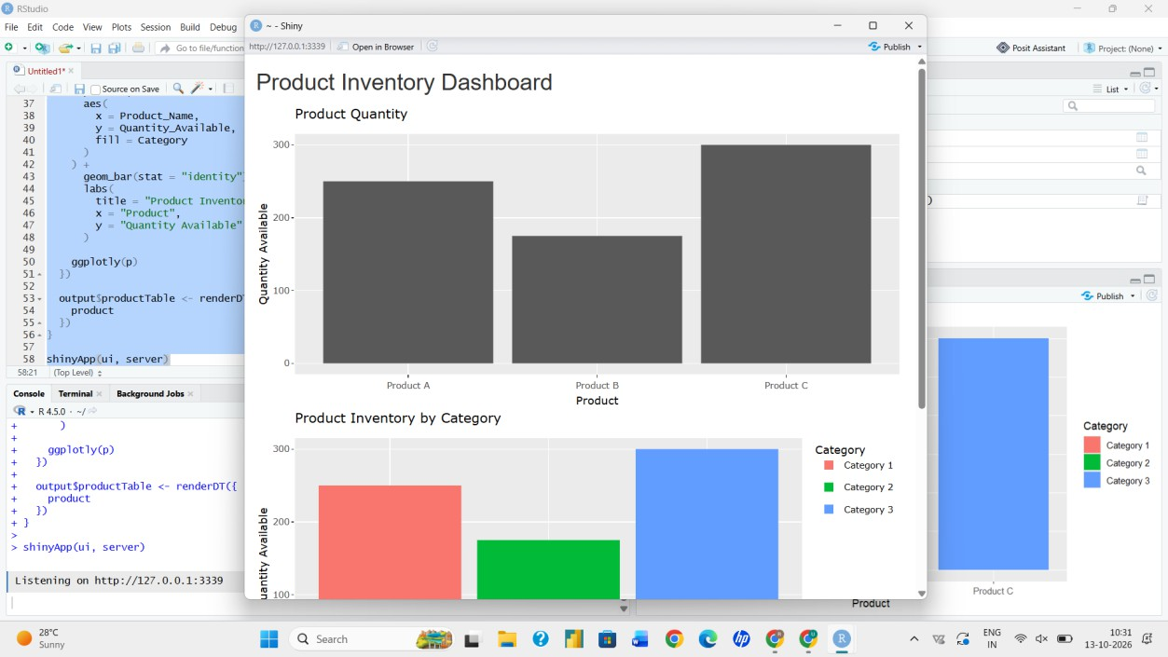

Question 2: Generate a Stacked Bar Chart
The given dataset does not contain a category column. Therefore, a category column is added for demonstrating the stacked bar chart.
R Code product$Category <- c( "Category 1",
"Category 2",
"Category 3"
)

ggplot( product, aes(
x = Product_Name,
y = Quantity_Available,

fill = Category
)
) +
geom_bar(stat = "identity") + labs(
title = "Stacked Bar Chart of Product Inventory", x = "Product",
y = "Quantity Available", fill = "Category"
)

Result
The stacked bar chart displays the quantity of each product according to the assigned categories.

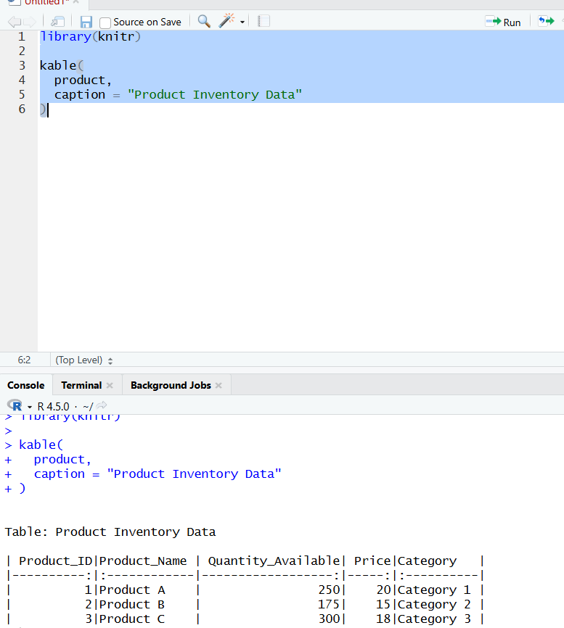

Question 3: Build a Table for Inventory Data R Code
product

Result
The table displays Product ID, Product Name, Quantity Available, Price, and Category.

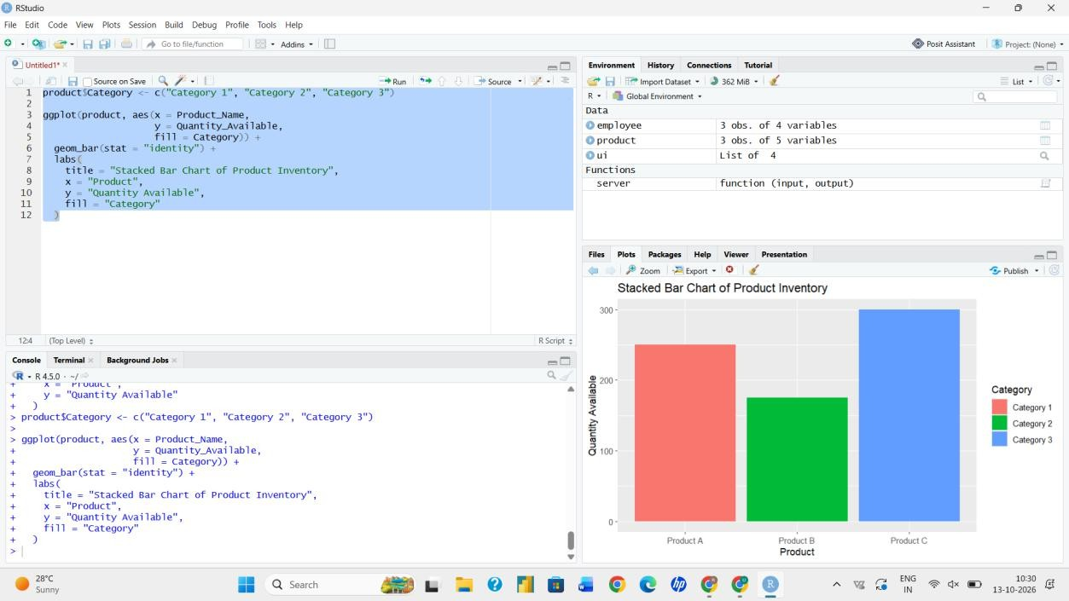

Question 4: Create an Interactive Dashboard R Code
library(shiny) library(ggplot2) library(plotly) library(DT)

ui <- fluidPage(
titlePanel("Product Inventory Dashboard"),

plotlyOutput("quantityPlot"), plotlyOutput("stackedPlot"), DTOutput("productTable")
)

server <- function(input, output) {

output$quantityPlot <- renderPlotly({

p <- ggplot( product, aes(
x = Product_Name,
y = Quantity_Available
)
) +
geom_bar(stat = "identity") + labs(
title = "Product Quantity", x = "Product",
y = "Quantity Available"
)

ggplotly(p)
})

output$stackedPlot <- renderPlotly({

p <- ggplot( product, aes(
x = Product_Name,
y = Quantity_Available, fill = Category
)
) +
geom_bar(stat = "identity") +

labs(
title = "Product Inventory by Category", x = "Product",
y = "Quantity Available"
)

ggplotly(p)
})

output$productTable <- renderDT({ product
})
}

shinyApp(ui, server)
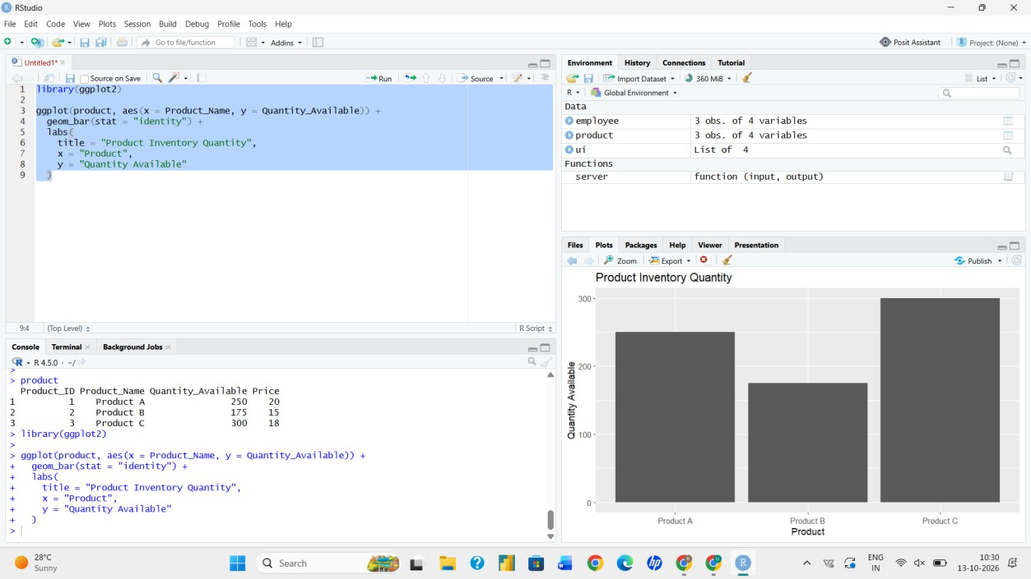

Result
An interactive product inventory dashboard is created containing the product quantity bar chart, stacked bar chart, and inventory table.

Conclusion
Product inventory data was successfully analyzed using R. Bar charts, a stacked bar chart, a table, and an interactive dashboard were created to understand product inventory information.

